Product(s) |  |  | Quantity x cost of item | Total for Item(s) $$
Free Will- A Young Man’s Spiritual Journey $25.99 | 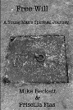
Free Will- The Angles Aftermath $25.99

Free Will Bundle-  Both Books $40.99 | &
Christianity at a Crossroads $35.99 | A Look at Modern American Christianity Through the Eyes of the Seven Churches of Revelation
Christianity at a Crossroads (10-books) $290.99 | Sunday School/ Bible Study Bundle (Save 20%)
Evangelism Shirt Series  “Dead Men Have No Rights” Tee Shirt $23.99 | Small  Medium  Large  Extra Large (XL) | Please add $2 more  2 Extra Large (2XL)  3 Extra Large (3XL)
Evangelism Shirt Series  “The FAITH is Strong with this One” Short Tee Shirt $23.99 | Small  Medium  Large  Extra Large (XL) | Please add $2 more  2 Extra Large (2XL)  3 Extra Large (3XL) | 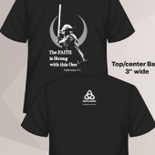
Evangelism Shirt Series  “Only You Can Prevent Eternal Fires” Short Tee Shirt $23.99 | Small  Medium  Large  Extra Large (XL) | 2 Extra Large (2XL)  3 Extra Large (3XL)
Evangelism Shirt Series  “Only You Can Prevent Eternal Fires” Long Tee Shirt $27.99 | Small  Medium  Large  Extra Large (XL) | 2 Extra Large (2XL)  3 Extra Large (3XL) | 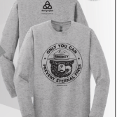
Evangelism Shirt Series  “The Holy Spirit” Short Tee Shirt $23.99 | Small  Medium  Large  Extra Large (XL) | 2 Extra Large (2XL)  3 Extra Large (3XL) | 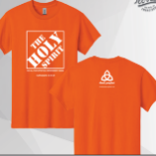
Evangelism Shirt Series  “The Holy Spirit” Long Tee Shirt $27.99 | Small  Medium  Large  Extra Large (XL) | 2 Extra Large (2XL)  3 Extra Large (3XL) | 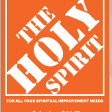
Evangelism Shirt Series  “The Holy Spirit” Hooded Sweatshirt $39.99 | Small  Medium  Large  Extra Large (XL) | 2 Extra Large (2XL)  3 Extra Large (3XL) | 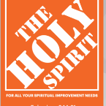
Bistro 12 oz Coffee Mug with Logo $11.99
Bistro 16 oz Coffee Mug with Logo $17.99
Large Zip Tote Bag with Logo $29.99
20 oz Travel Mug with Logo $23.99 |  |  | 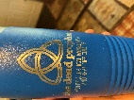
Live worship CD- Mike & Shanna Beckett- Taste & See” Remastered $10.99
Monthly supporter | $25 dollars a month |  | $300-dollars onetime payment (free thank you gift)
 |  |  | Total Items =  Tax add 6% to total | Total Cost =  $  Tax=
 |  |  | PLUS Shipping & Processing Costs  $10-45 dollars= $6.95  $46-100 dollars= $10.95  $101-149 dollars= $15.95  $150 dollars and up= $19.99 | $
 |  |  | Your Total Cost | $
Please make check or money order out to “Dead Prophet Media” Mail order form to The Dead Prophet P.O. Box 302 DuBois, PA 15801. If you send cash, we are not responsible if it is stolen in transit to our office. You can also order online at https://thedeadprophet.net/shop/ Please allow 3-4 weeks from the time order is received for delivery to arrive.
Ship to:

Name

Mailing Address

Contact Number
Email

